Overall Theme
Our next swim event is the “ASC Spooky Splash Spectacular“ It is a fall halloween themed swim meet. It should not be scary but focus on cliche halloween things that are fun for all ages.:

- Pumpkins
- Ghosts
- Witches
- Mummy
- Zombie
- Bats
- Spider Webs
- Autumn Leaves

Colors and Font
Colors are Halloween and Fall. Think of Orange, Yellow, Brown, Black, White, Green, Purple.

Choose a spooky font similar to these:
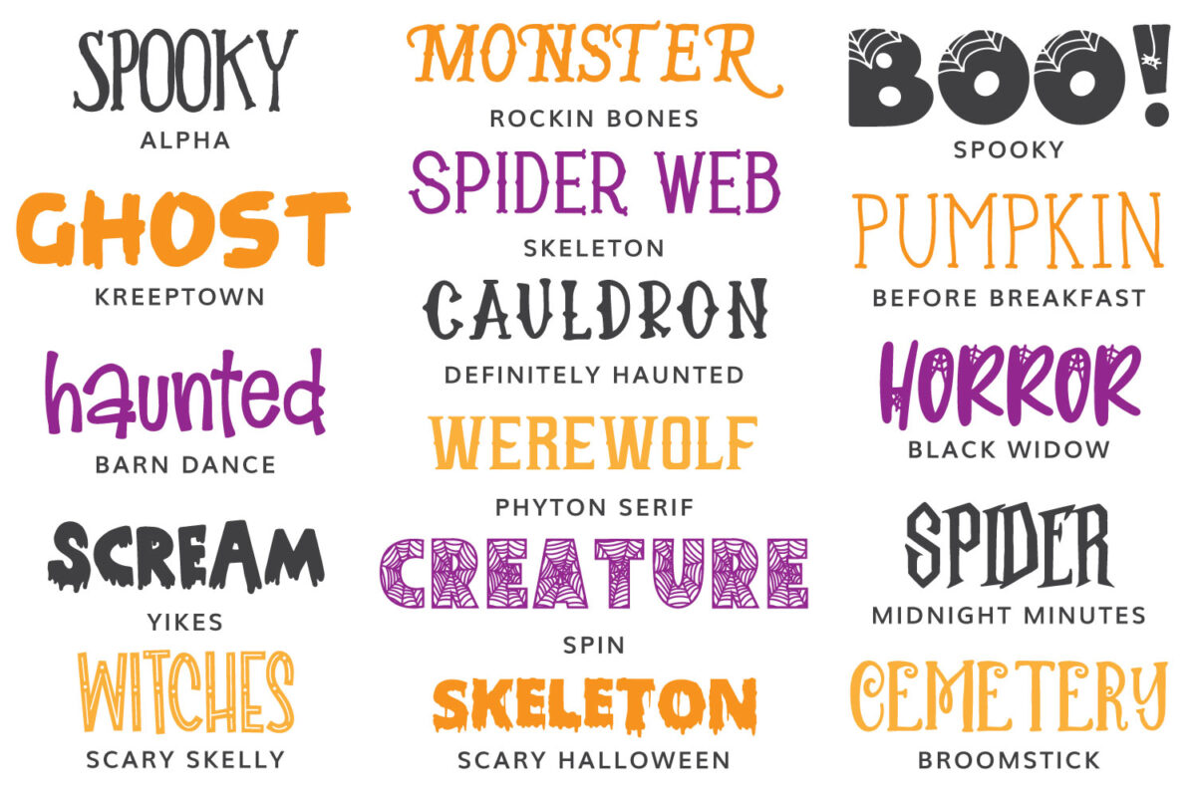

Information About your Pool

Number of Lanes | 8
Length | 25 Yards
Lane Numbering | Lane 1 is at the bottom of the picture and they count upward to 8

Header
The Header should contain the event number followed by the Heat number. In the center should be a banner that will hold the event name. If the event name is too large for the banner, it should use scrolling text. Also leave enough room in the header for the timer to be on the left side. Here is an example from a previous theme.

The header should have a grave yard theme with the event number and heat number appearing as gravestones with the numbers etched large on them. The Event name should be a coffin that opens and closes with the event name popping out and appearing on the opened coffin door.

The timer should be added to the header.

Header Animations
When a new Event Begins, a random halloween character should run across the header. These characters should be a Ghost, Zombie, Mummy, and a Witch.

Timer
The Timer should appear when the race is running and disappear when the race is finished. We would like the clock to appear as a Running zombie.. A Digital display of time should also be displayed.

Lane Overlay

Trigger | Description of Appearance | Animation on Appearance | Animation of Disappearance
On Start | Swimmers names should appear when the heat number is changed. It should also show the swimmes’ club name | Slide in from the right | Should explode
Race Running | nothing
New Split Available | The split time should appear in the lane marker, this should just be the split time and nothing else | Slide out from right to left under the lane number marker | Slide in from left to right under the lane number marker
Lane Finished | When a race is finished, the lane should indicate the place that the swimmer finished in and their finishing time | Lane marker should slide in from the right | Just disappear
Race Done | When the race is finished. The Finish times along with the place should be shown to the left of the lane marker. | A spider should build a web in the left corner of the screen | Fade out

How to show the lane numbers
Lane numbers should appear as carved jack o'lanterns with the numbers inside of them. They should appear on the right side of the screen.

What to do when a swimmer is not in the lane
When a name is not assigned to a lane, do not show anything in the Overlay for this lane. If you do receive a split or a finish time for the lane this means that there is actually a swimmer and the lane should become active again showing the number, split times and finish time.

